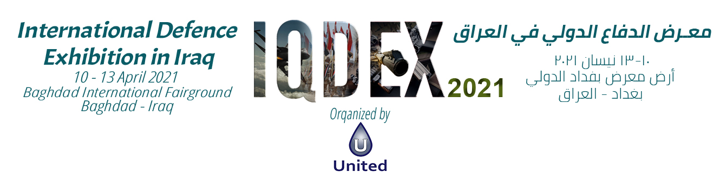

EXHIBITION SPACE CONTRACT STAND #:
EXHIBITOR DETAILS

Company Details
Company Name:

Address:

City: State:
Country:
Telephone:
Postcode/Zip code:
Website:
Fax:

Main Point of Contact
Contact Name: Direct Dial:

Position: Mobile:

E-mail:

EXHIBIT SPACE OPTIONS & PRICES
Please tick all items that are applicable to you and complete the blank areas.
A

PLAN
INTERNAL AREA (Minimum 18m²) |  | DIMENSIONS | HEIGHT | TOTAL SPACE | TOTAL PRICE
Equipped Area ($625/m²) | m x m |  | m | m² | $
Not Equipped Area ($550/m²) | m x m |  | m | m² | $
Note : In case of lockdown or emergency due to the pandemic, free cancellation apply

Please select one of the below options:
Corner (open to 2 aisles)  %3+ on space total | Peninsula (open to 3 aisles)  %5 + on space total | Island (open 4 aisles)  %6 + on space total
Amount: $ Amount: $ Amount: $

Note: 5% additional fees will be applied on each square meter exceeds 3 meters’ height for Not Equipped Area (special design) booth.
TAX 6% | $
TOTAL PAYMENT | $
To be fully received by 8th January 2021 | $

PLAN B

EXTERNAL AREA (Minimum 50m2) | DIMENSIONS | TOTAL SPACE | TOTAL PRICE
Outdoor Space ($350/m²) | m x m | m² | $

TAX 6% | $
TOTAL PAYMENT | $
To be received by 8th January 2021 | $

PLAN C

For the companies who wish to book internal and external areas:
Note: If the building of the booth is referred to a local or foreign contractor other than the companies approved by the organizer, the beneficiary company shall pay an amount of (25 $) twenty-five additional US dollars for each square meter of the total area executed.
Plan A Total Payment
Plan B Total Payment
GRAND TOTAL (A + B)

PAYMENT DETAILS

Payment Terms
- Total amount due is payable to UNITED COMPANY on receipt of our invoice by Jan 8th 2021.
- If the payment was delayed more than one month from the Exhibition date, then delay charges will apply, 4% per one-month delay.

Invoice Details (If different from company details) and Payment Method

Will be provided after signing the contract.

SIGNATURES
Falah H. Raheem  UNITED COMPANY  CEO  Date: | By signing the present application, we formally agree to abide by the terms and conditions overleaf.  This application must be signed by a person duly authorized.  For and on behalf of the exhibiting company  Company Name:
Signature and stamp: Position in company:
Date:
Signature and stamp:

LEGAL TERMS

1. ADVERTISING MATTER
The Exhibitor may distribute, only within the confines of its stand, hand bills or other printed advertising matter with respect to its exhibit. The Organizer reserves the right to prohibit the distribution of any advertising material for any reason whatsoever.

2. ALLOCATION
- Exhibit space will be allocated according to the date of booking and signing the contract.
- The organizer shall have full discretion in the location of the exhibition according to the exhibition plan and the imposed restrictions, in a manner that does not affect the reserved area of the beneficiary company.
- No change will be made by the organizer unless informing the exhibitors. The Organizer agrees to advise the Exhibitor if such a change is necessary.
- The Organizer’s determination with respect to allocation of exhibit space is to be binding on the Exhibitor.
- The full contract price shall at all times be payable even if the Exhibitor eventually does not utilize all the exhibit space allocated to him.
- If desired, the Exhibitor may provide the Organizer with a list of competitors whose exhibits (if any) should not be near that of the Exhibitor. The Organizer will, where practicable, accommodate such requests.

3. CANCELLATION
- Except as otherwise provided herein, no refund will be made of any money paid to the Organizer in the event of the Exhibitor deciding not to participate and/or decreasing his participation in the Exhibition or if the Organizer terminates this Agreement for a material breach of this Agreement by the Exhibitor.
- . If the Exhibitor decides to cancel participation or decrease the space on or before 31 December 2020, the Exhibitor is liable to pay 75% of the total area cost.
- If the Exhibitor decides to cancel or decrease his participation after 31 December 2020, the Exhibitor is liable to pay 100% of the total area cost.

4. EXHIBIT CLEANING
The Exhibitors must make arrangements for its exhibits to be kept presentable, clean and free from accumulated rubbish to the satisfaction of the Organizer. All material for disposal as waste must be deposited in the areas designated by the Organizer.

5. LEGALLY BINDING
This Agreement shall enter into force and be deemed to take effect as a legally binding agreement immediately on signature.

6. PROHIBITED EXHIBITS
Unless approved in writing by the Organizer, strictly no live military equipment, including but not limited to such items as munitions, aircraft armament, small arms ammunition and explosives, weapon systems tactical missiles, rockets, etc., shall be brought onto the Exhibition premises. Other kinds of exhibits may be prohibited by the Organizer.

7. PUBLIC SAFETY INSURANCE AND EXHIBITION LIABILITIES
The Organizer recommends that all exhibitors provide their own insurance coverage. In case of any accidents, the organizer will not be responsible for any damages.

8. SAFETY, FIRE, HEALTH AND OTHER LAWS
All fire, safety, health and other laws, rules and regulations imposed by local authorities and agencies or the lessor of the premises where the Exhibition is held must be strictly observed by the Exhibitor. Aisles and fire exits shall not be blocked by exhibits. Decoration of the exhibits shall only be carried out in such manner approved by the Organizer. No storage behind exhibits is provided or permitted.

9. SOUND LEVEL
Mechanical or Electrical devices which produce sound must be operated so as not to prove disturbing to other Exhibitors. The Organizer reserves the right to determine the acceptable sound level in all such instances and to require the removal of any such devices.

10. TERMINATION
The Organizer may terminate this Agreement without liability to Exhibitor immediately on giving notice to the Exhibitor if:

- the Exhibitor commits a material breach of this Agreement.
- If the exhibitor fails to pay or make payments due to the Organizer under this Agreement on the due date of payment, it shall be a material breach of this Agreement. And under go to legal accountability.
- the Exhibitor suspends, or threatens to suspend, payment of its debts, is unable to pay its debts as they fall due or admits inability to pay its debts will undergo to the standing law.
- This contract is a confidential document between the organizer and the exhibitor. Otherwise, the exhibitor shall be liable to a fine of 20,0000$.
- All display contents and personal items of the exhibitors during the show hours are the responsibility of the exhibitor towards all accidents.
- In case of contracting within the exhibition land, the contracting company shall pay the exhibition commission to the organized company which proportion is 0.50%.

11. EXHIBITION ’S INVITATION
The official Exhibition ‘s Invitation is a part of this contract.

ADDITIONAL SERVICES

Note: Rental cost is for four days of the exhibition.
 | Name | Price | Sample | No of unit | Total Price
1 | Round Table | $70 | 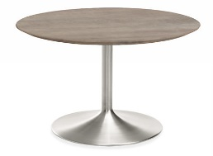
2 | Chair White Plastic Chair | $25 | 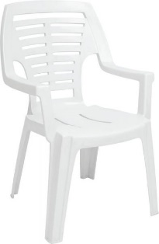
3 | Spot Light 150Watt | $30 | 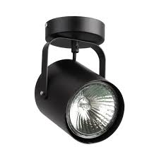
4 | Desk Table | $200 | 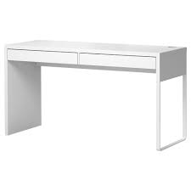

5 | TV (50 inch) | $350 | 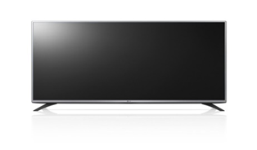
6 | Glass Vitrine | $150 | 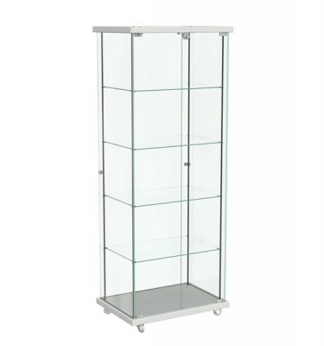
7 | Shelf | $25 | 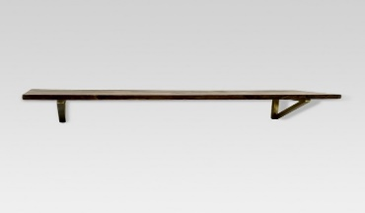
8 | Exhibitor | $100
9 | Fridge | $150 | 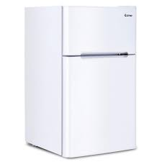

10 | Water Chiller | $120 | 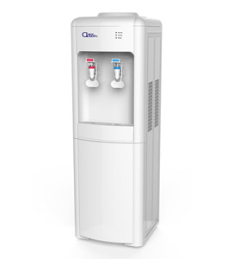
11 | Brochure Stand | $100 | 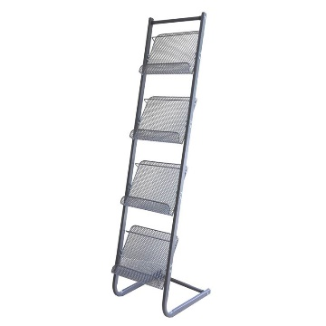
12 | Reception table | $100 | 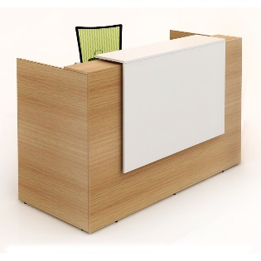

Note: Images above for additional services items are not same as those in real, it just to illustrate the idea.

SPONSORSHIP

STRATEGIC SPONSOR (one sponsors is allowed): $ 150,000 and has the following privileges:
a. 36 m² free special design (not equipped) internal booth with the logo of the ninth session with the company logo with parquet floor with a 50-inch LED screen with a meeting table for six people with chairs and a trash can and a storage room of 3 m x 3 m.
b. The strategic sponsor logo is printed on all prints of the exhibition.
c. The strategic sponsor's logo and the logo of the exhibition are printed on the closing and opening ribbon of the exhibition booths.
d. VIP car for strategic sponsor from the airport to the hotel and from the hotel to the exhibition and vice versa throughout the days of the exhibition.
e. hotel suite booking for four days.
f. The company's logo is on the cover of the exhibition catalogue, with two internal pages.

DIAMOND SPONSOR (three sponsors are allowed): $ 40,000 and has the following privileges:
a. A free internal booth of 24 m² is not equipped.
b. Print the company logo on all prints.
c. Two full internal pages in the exhibition catalogue.
d. VIP car from the hotel to the exhibition and vice versa throughout the days of the exhibition.

GOLDEN SPONSOR (two sponsors are allowed): $ 30,000 and has the following privileges:
a. A free internal booth of 18 m² is not equipped.
b. Print the company logo on all prints.
c. A full internal page in the exhibition catalogue.

MEDIA SPONSOR (one sponsors is allowed): $ 20,000 and has the following privileges:
a. Put the company logo on all prints.
b. A Roll-Up at the entrance of the exhibition represents the logo of the media sponsor with an advertising he prefers.

TECHNICAL SPONSOR (three sponsors are allowed): $ 10,000 and has the following privileges:
put an advertising with company logo on (Kiosk) Mobile charging.

